**Introduction to GIT Commands :**

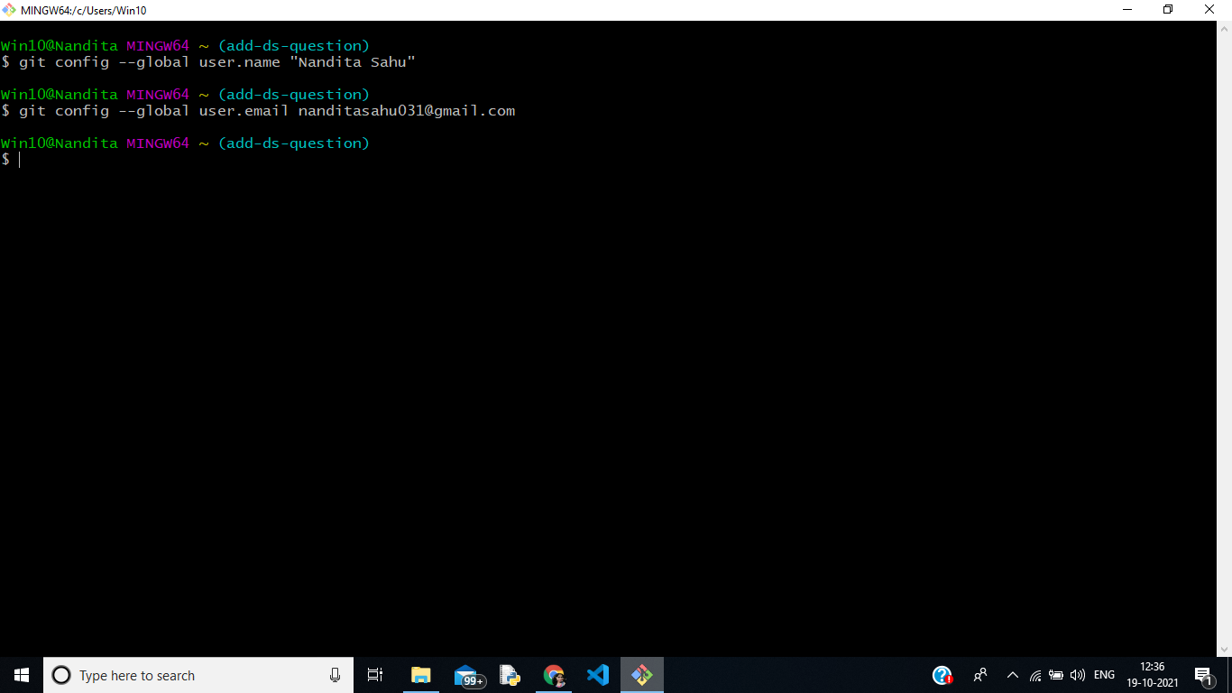

**1.global user.name command is used to set “Username” in the global configuration settings.**

**2.global user.email command is used to set “Email” in the global configuration settings**

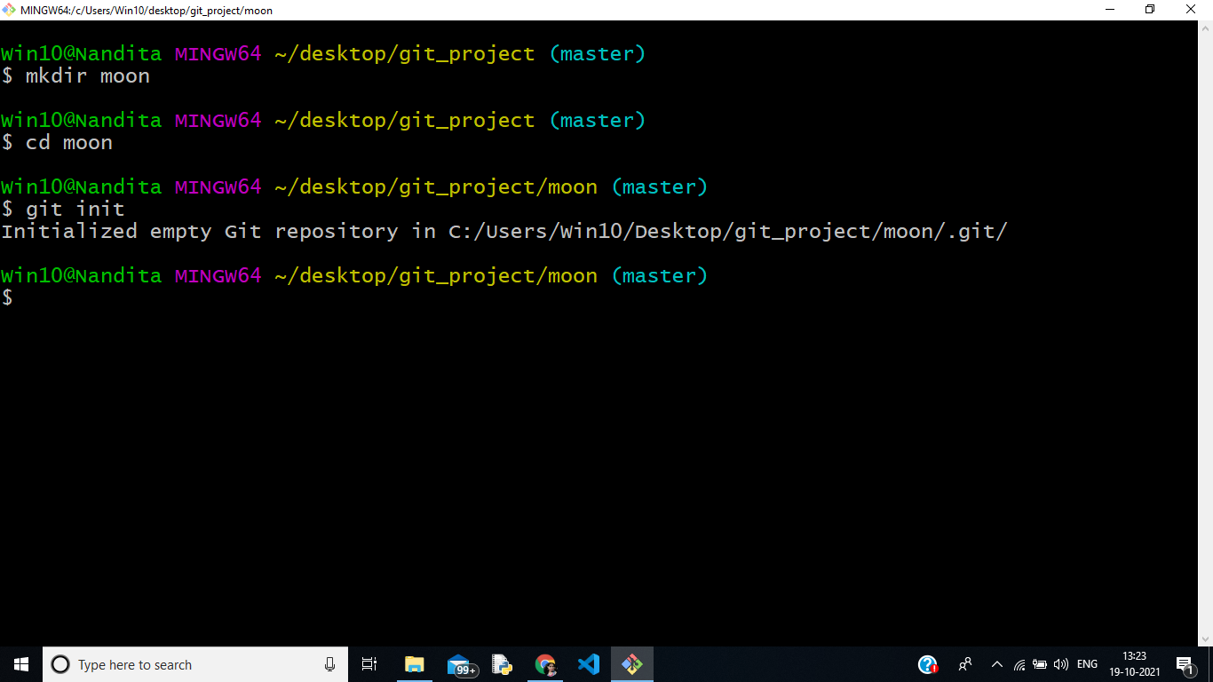

**1.Making a directory named Moon and changing directory**

**2. Git init is to create a .git repository in the local working directory**

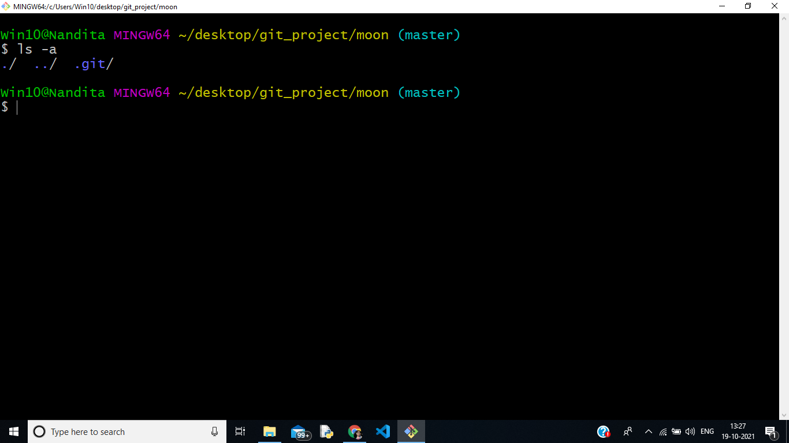

**1.Checking the files present in present working directory by ls -a command**

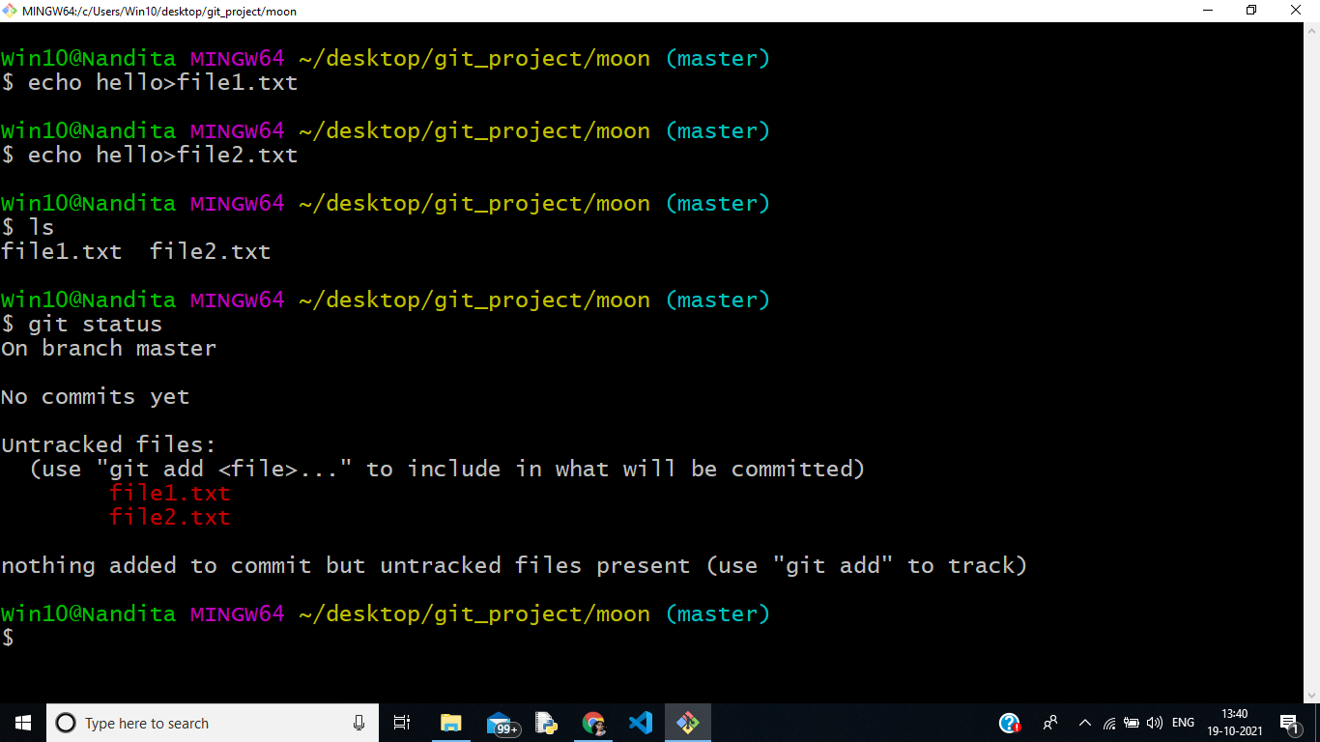

1. **Creating 2 files(file1.txt and file2.txt). Checking the status of the files by git status command.**
2. **The status shows that both the files are untracked.**

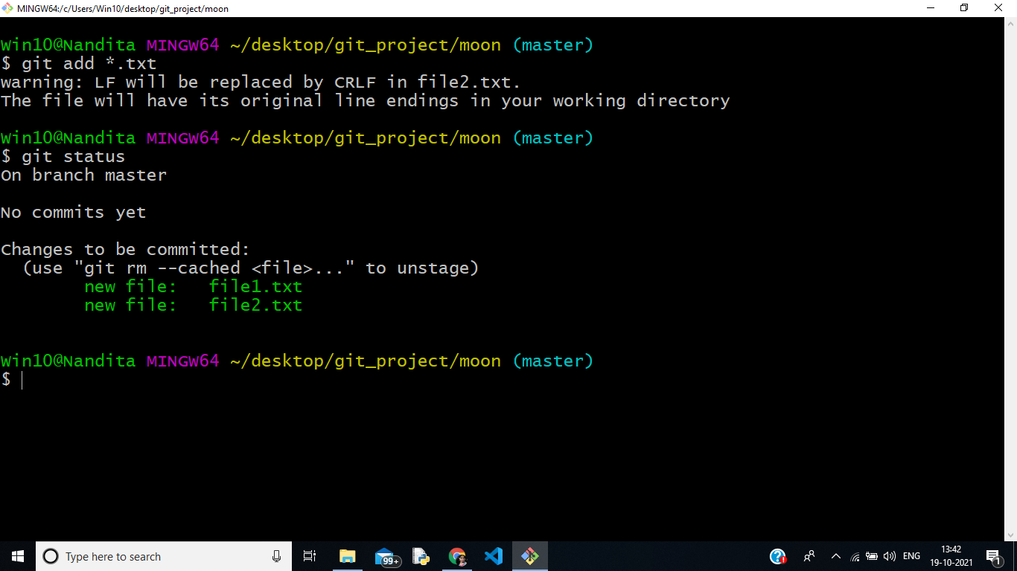

1. **By git add . , we are able to add all pwd files from working area to staged area.We can check through status , that they are tracked.**

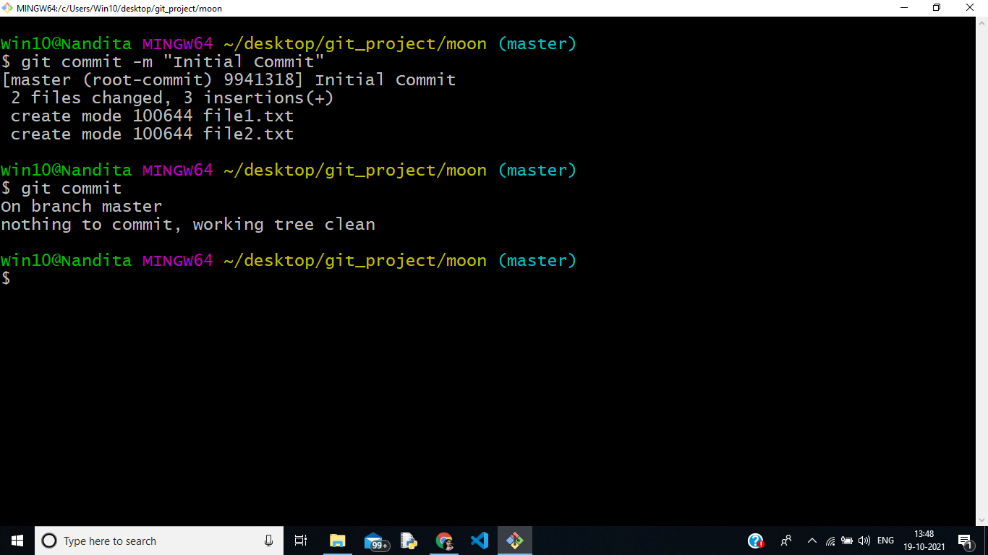

1. **Done first commit . By using commit command git creates a snapshot of the project current staged changes.**

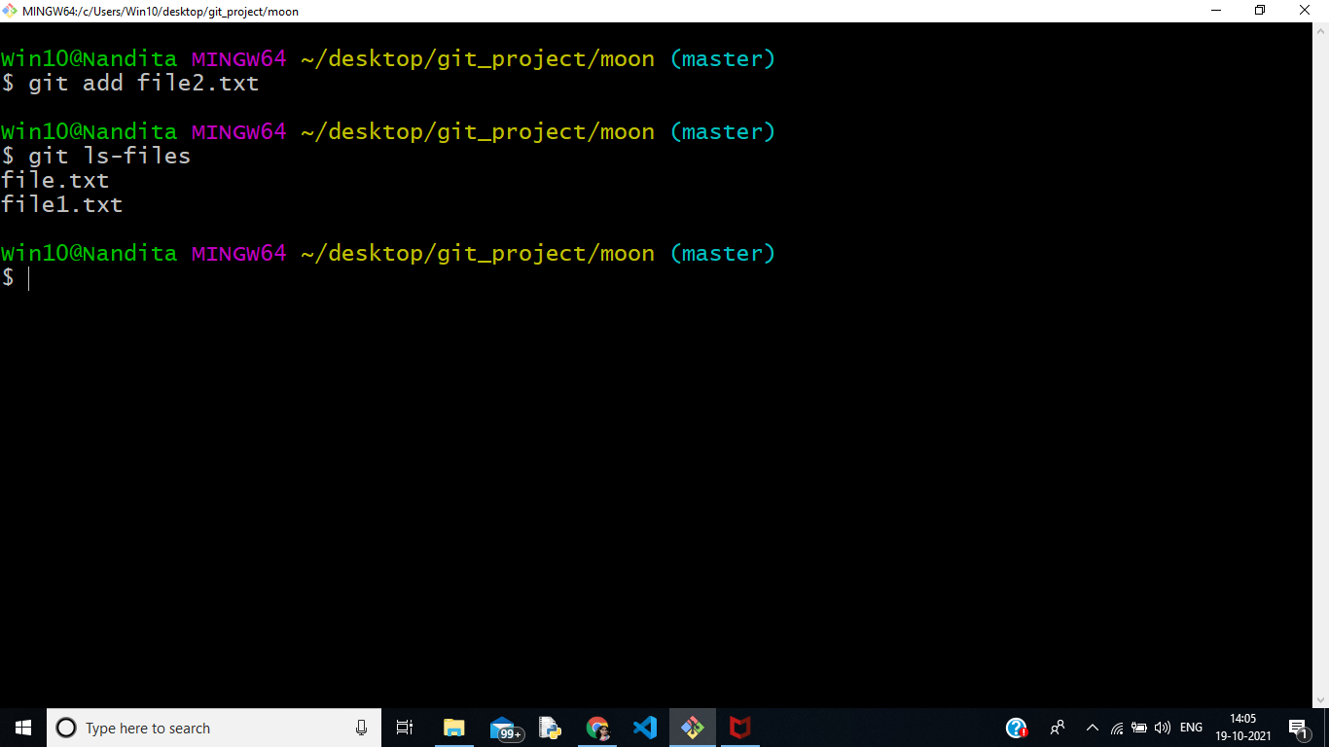

1. **Git ls-files shows all files present in pwd**

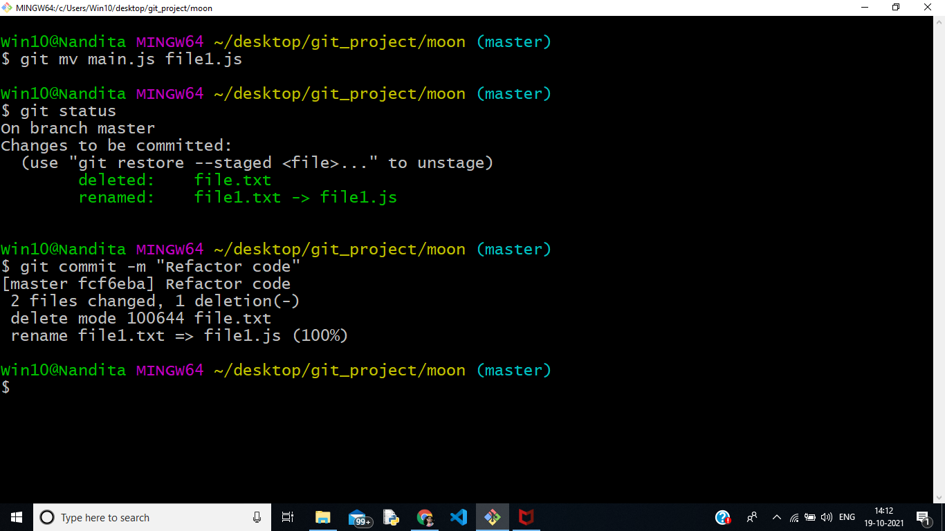

1. **Rename file from main.js to file1.js (Deleting and Renaming, both operations takes place)**

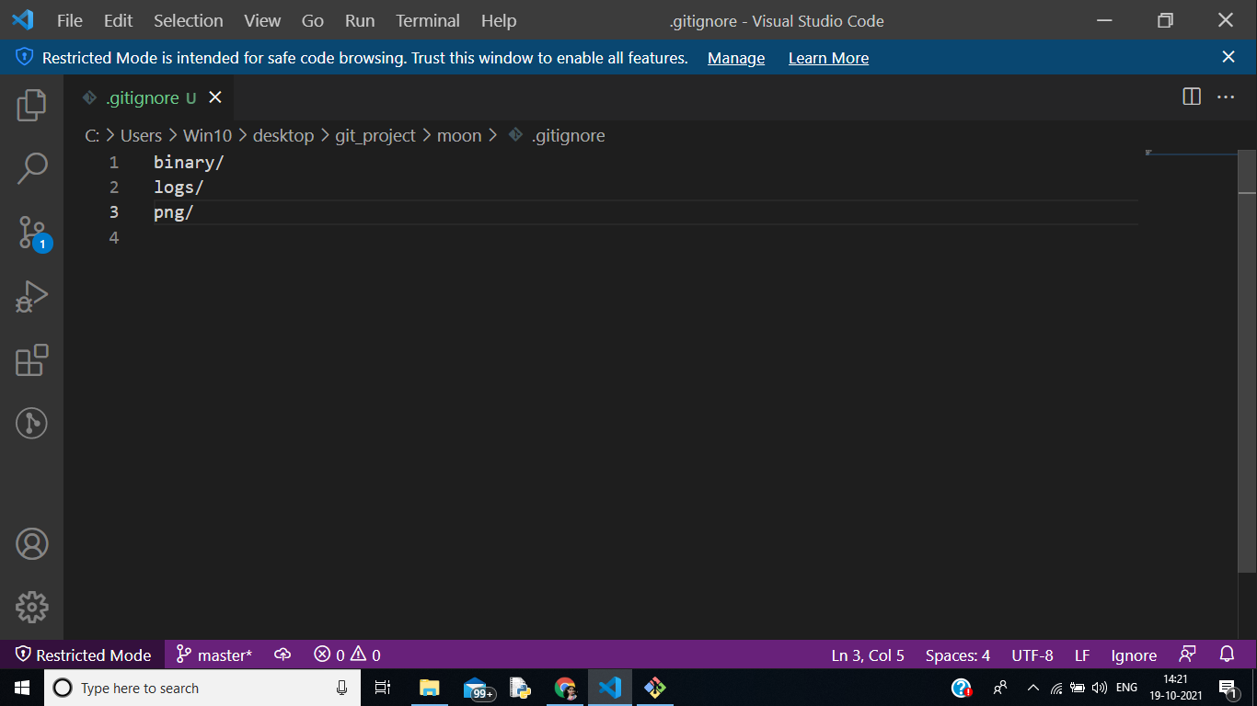

1. **Creating .gitignore file contains those files and folders that you don’t want to upload in master repository.**

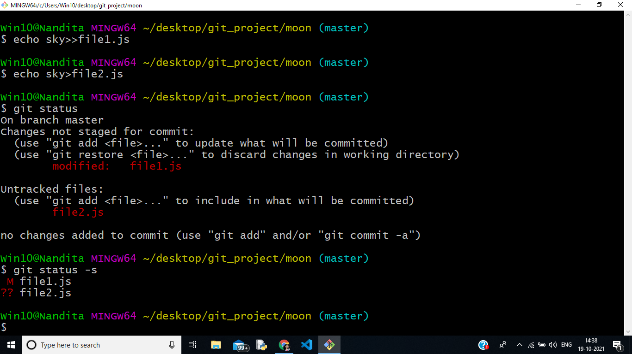

1. **Git status -s is used for short form for status.**
2. **Here M in file1.js shows that changes made in file1.js in untracked area and only modified in working area.**

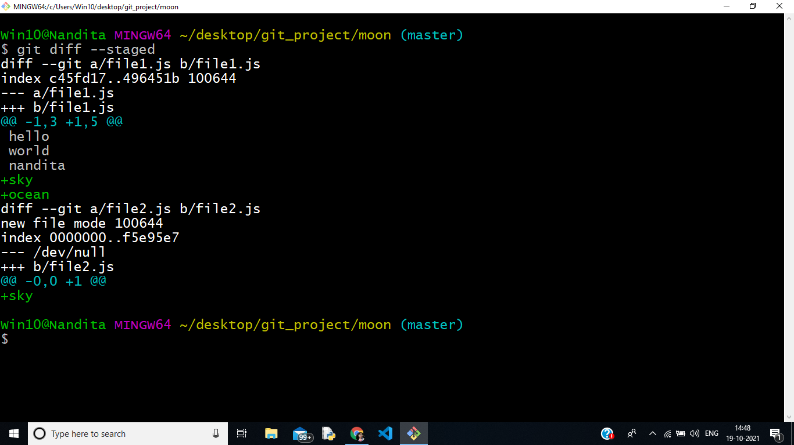

1. **Git diff --staged here shows difference of file1.js in staging area**

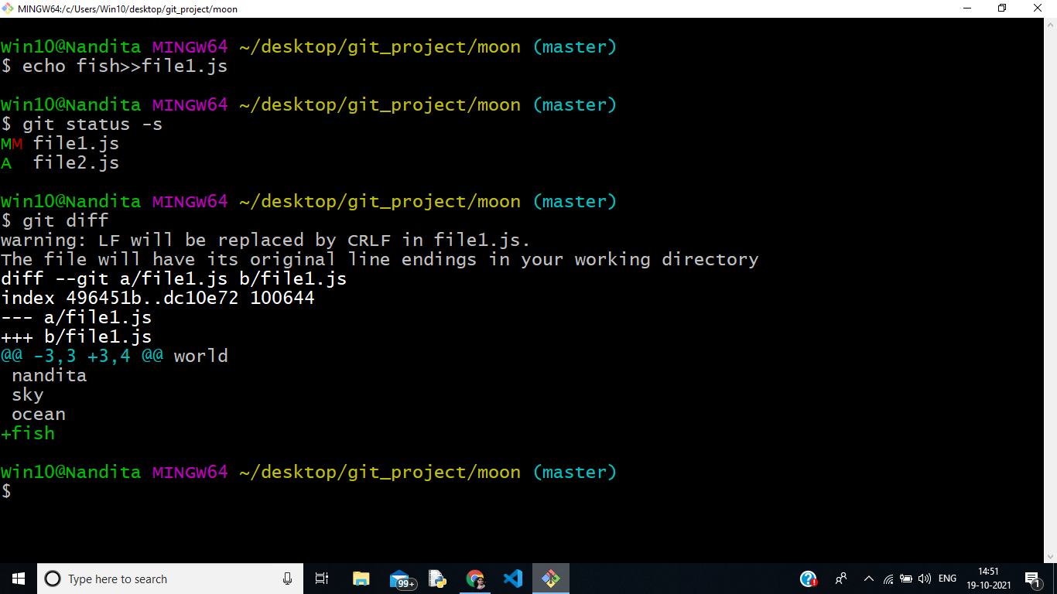

1. **Git diff shows difference in working directory**

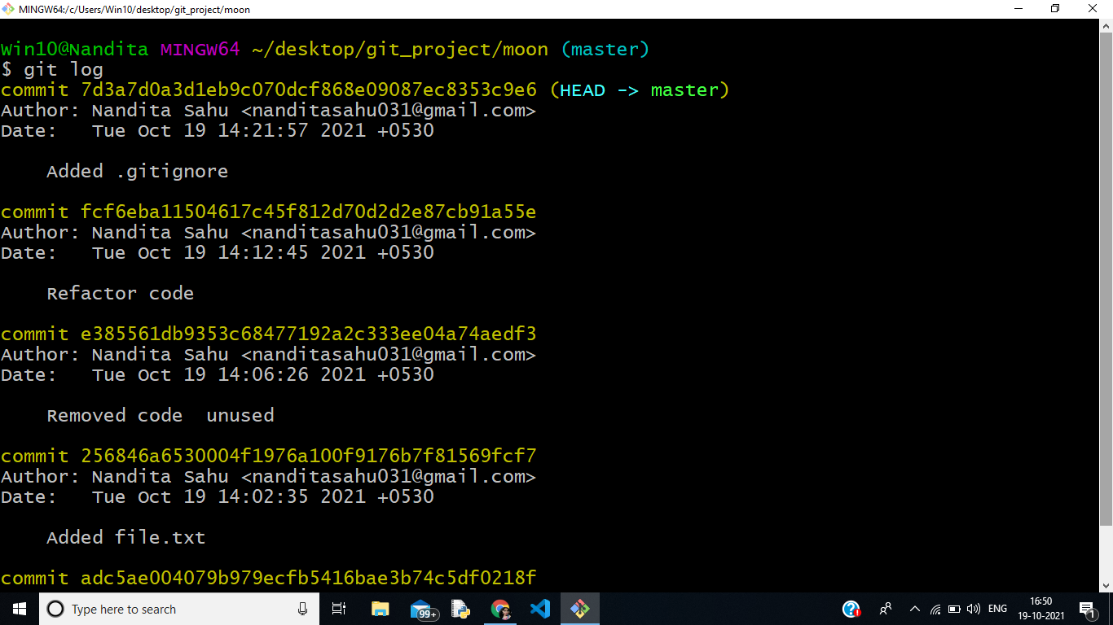

1. **Git log is used for history of repository**

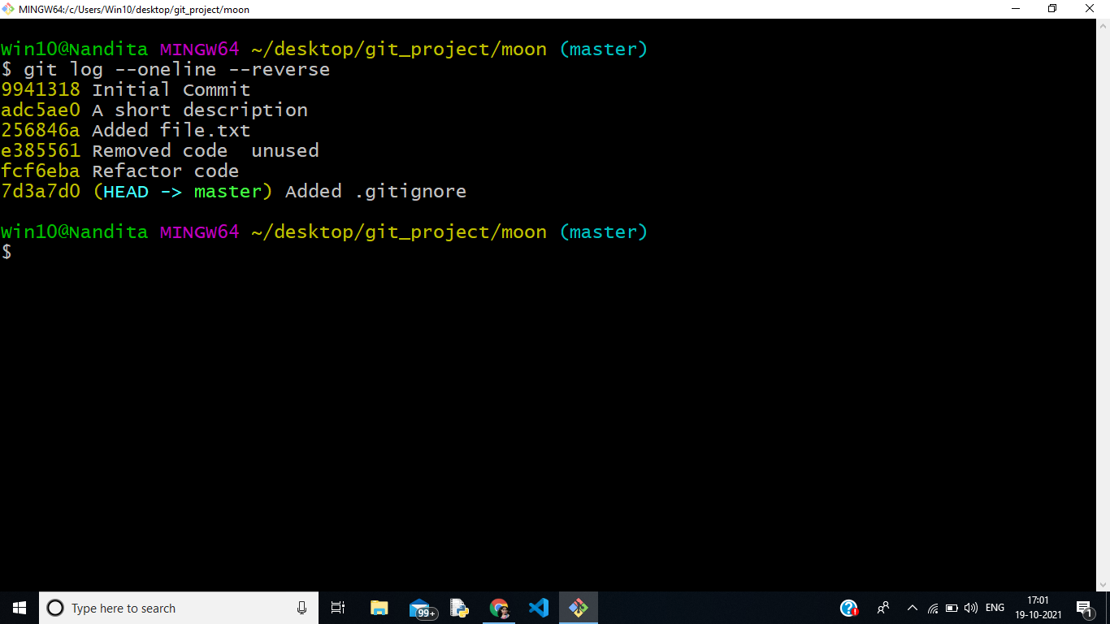

1. **One Line commit Message (Short form for git log)**

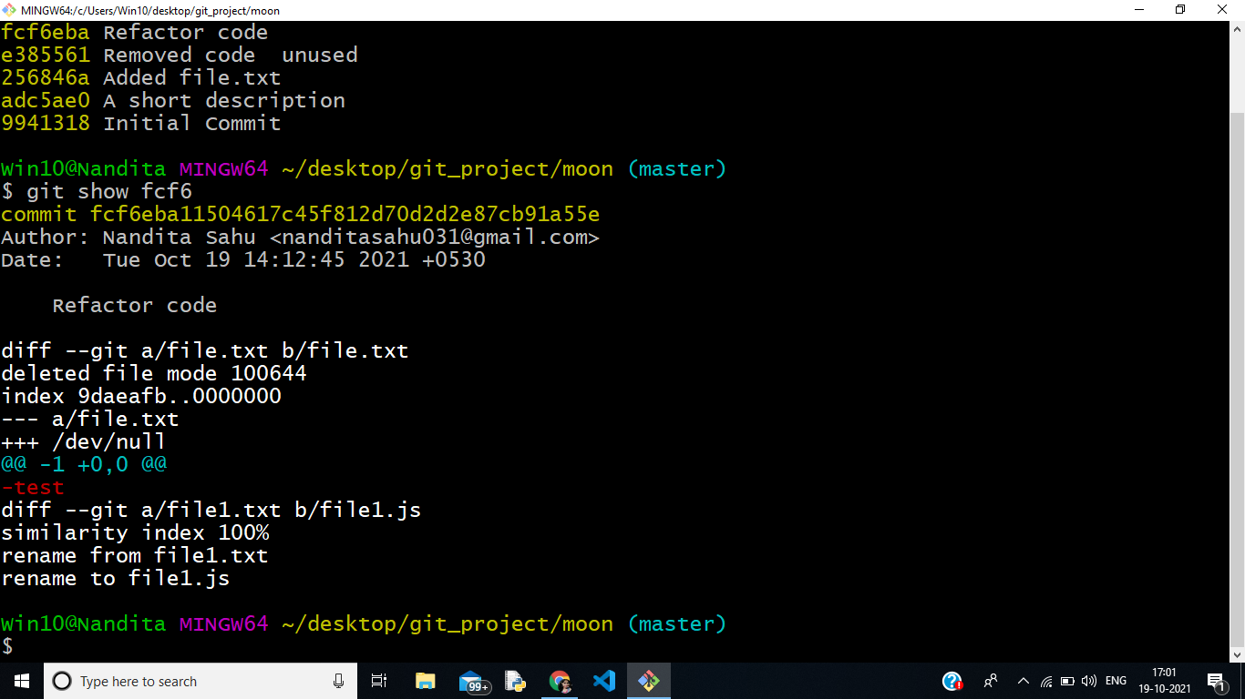

1. **Git show is used details of the git objects(commits)**

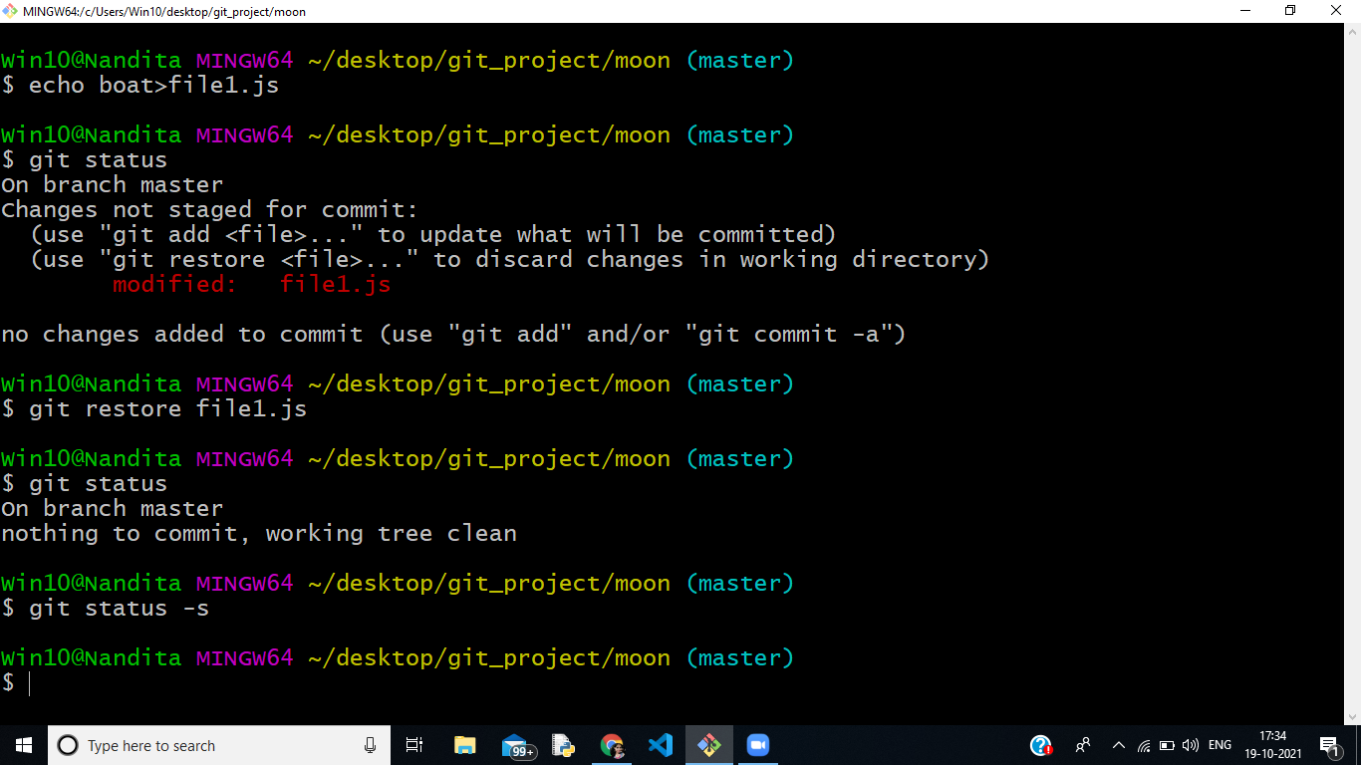

1. **Git restore filename is used to remove changes from working area if the file created is in untracked mode .It is used for changes in the working area or change content in staged area.**